**Digital Music Store Analysis**

**Objective**- To examine the database with SQL and help the store understand its business growth by answering simple questions.

**/*Q.1 Who is senior most employee based on job title?*/**

**Query**

select * from employee

order by levels desc

limit 1

**Output**



**/*Q.2 Which country have most invoice?*/**

**Query**

select count(*) as c, billing_country

from invoice

group by billing_country

order by c desc

**Output**

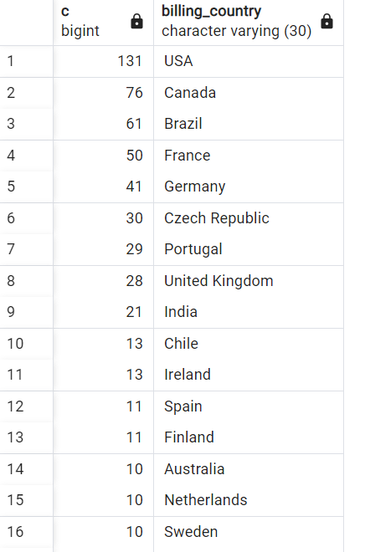

**/*Q.3 What are top 3 values of total invoice?*/**

**Query**

select total from invoice

order by total desc

limit 3

**Output**

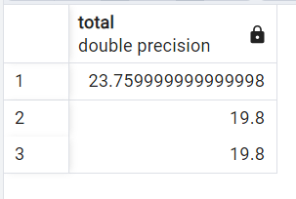

**/*Q.4 Which city has best customers?*/**

**Query**

select sum(total) as invoice_total, billing_city

from invoice

group by billing_city

order by invoice_total desc

**Output**

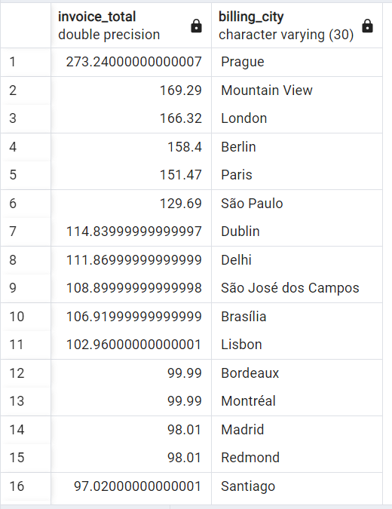

-**-Q.5 Who is best customer?The customer who has spent the most money money**

**-- will be declared as best cutomer. Write a query that return the person**

**--who has spent the most money**

**Query**

select customer.customer_id, customer.first_name, customer.last_name, sum(invoice.total) as total

from customer

join invoice on customer.customer_id=invoice.customer_id

group by customer.customer_id

order by total desc

limit 1

**Output**

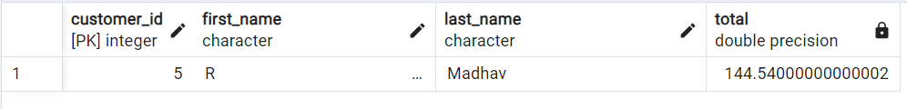

**--Q.6 Write a query to return the email, first name, last name & genre of all rock music listeners.**

**--Return you list ordered alphabatically by email starting by A**

**Query**

select distinct email, first_name, last_name

from customer

join invoice on customer.customer_id=invoice.customer_id

join invoice_line on invoice.invoice_id=invoice_line.invoice_id

where track_id in(

select track_id from track

join genre on track.genre_id=genre.genre_id

where genre.name like 'Rock'

)

order by email;

**Output**

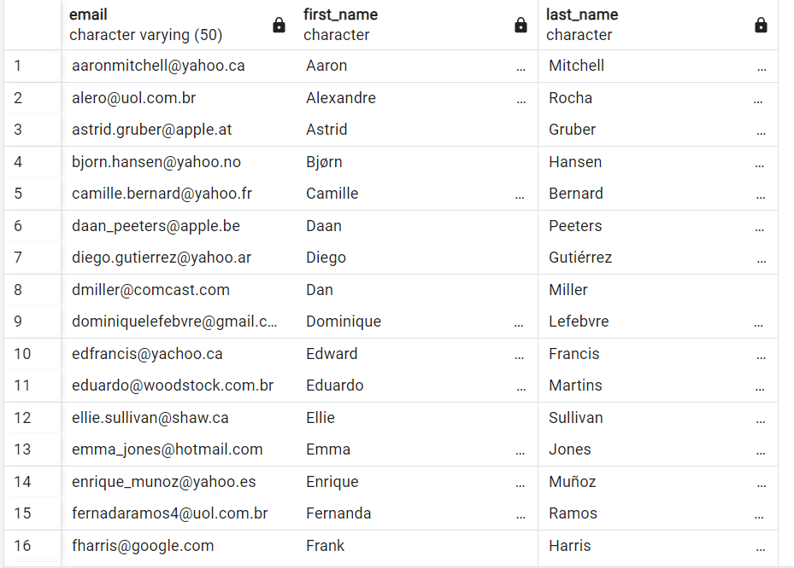

**--Q.7 Let's invite the artist who have written the most rock music in out dataset. Write a query**

**--that returns the artist name and total track count of top 10 rock bands.**

**Query**

select artist.artist_id, artist.name, count(artist.artist_id) as number_of_songs

from track

join album on album.album_id= track.album_id

join artist on artist.artist_id= album.artist_id

join genre on genre.genre_id= track.genre_id

where genre.name like 'Rock'

group by artist.artist_id

order by number_of_songs desc

limit 10;

**Output**

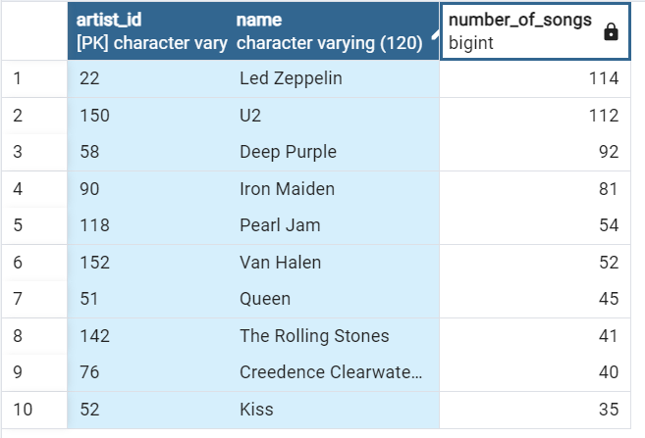

**--Q.8 Return all the track names that have a song length longer than the average song length.**

**--Return the name and miliseconds for each track. Order by the song length with the longest songs**

**--listed first.**

**Query**

select name,milliseconds

from track

where milliseconds>(

select avg(milliseconds) as avg_track_length

from track)

order by milliseconds desc;

**Output**

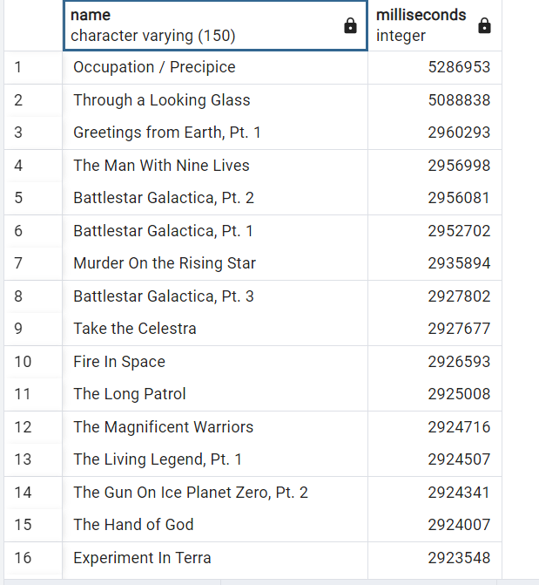

**--Q.9 How much amount spent by each customer on artists? Write a query to return customer name, artist name and total spent.**

**Query**

WITH best_selling_artist AS (

SELECT artist.artist_id AS artist_id, artist.name AS artist_name, SUM(invoice_line.unit_price*invoice_line.quantity) AS total_sales

FROM invoice_line

JOIN track ON track.track_id = invoice_line.track_id

JOIN album ON album.album_id = track.album_id

JOIN artist ON artist.artist_id = album.artist_id

GROUP BY 1

ORDER BY 3 DESC

LIMIT 1

)

SELECT c.customer_id, c.first_name, c.last_name, bsa.artist_name, SUM(il.unit_price*il.quantity) AS amount_spent

FROM invoice i

JOIN customer c ON c.customer_id = i.customer_id

JOIN invoice_line il ON il.invoice_id = i.invoice_id

JOIN track t ON t.track_id = il.track_id

JOIN album alb ON alb.album_id = t.album_id

JOIN best_selling_artist bsa ON bsa.artist_id = alb.artist_id

GROUP BY 1,2,3,4

ORDER BY 5 DESC;

**Output**

